AUTOMATED GARDEN WATERING SYSTEM USING ARDUINO

THE KISUMU NATIONAL POLYTECHNIC
BY
NAME: OLUOCH JOSHUA OOKO
INDEX: 7411050007
SERIES : JULY 2026
DEPARTMENT: ELECTRICAL AND ELECTRONIC

SUBMITTED TO THE KENYA NATIONAL EXAMINATION COUNCIL
(KNEC) IN PARTIAL FULFILMENT FOR THE AWARD OF DIPLOMA IN ELECTRICAL AND ELECTRONICS ENGINEERING (POWER OPTION)

DECLARATION
I hereby declare that this project report titled "Automated Garden Watering System Using Arduino" is my original work and has not been submitted for any any other institution of higher learning. All sources of information have been duly acknowledged.

Student's Declaration

OLUOCH JOSHUA OOKO

Signature: ___________________________ Date: ________________

Supervisor's Declaration

OKUNDI NOAH

Signature: _______________________ Date: ________________

DEDICATION

This project is dedicated to my beloved family, whose unwavering love, support, and encouragement have been the cornerstone of all my academic achievements. To my parents, who sacrificed so much to ensure I had access to quality education — your belief in me has kept me going through every challenge.

To my fellow students and colleagues in the Department of Electrical and Electronics Engineering, this work is also dedicated to you. May it serve as a stepping stone and an inspiration for future innovations in embedded systems and agricultural automation.

Finally, to all farmers who work tirelessly to put food on our tables — this project is a small contribution toward making your work easier and more efficient through the power of technology.

ACKNOWLEDGEMENT
First and foremost, I give praise and thanks to the Almighty God for the wisdom, strength, and perseverance He granted me throughout the entire duration of this project. Without His grace, none of this would have been possible.
I would like to express my profound gratitude to my project supervisor, whose invaluable guidance, patience, constructive criticism, and intellectual input were pivotal in shaping this work. Your mentorship went beyond academics and will remain an asset throughout my career.
I am also greatly indebted to the entire academic staff of the Department of Electrical and Electronics Engineering at Kisii University for providing me with the theoretical and practical foundation that made this project possible. The knowledge imparted in the lecture halls and laboratories has been indispensable.
My sincere appreciation goes to the university laboratory technicians for their support in providing access to the necessary tools and equipment during the construction and testing phases of this project. Your assistance was invaluable.
To my parents and family members — thank you for your endless moral and financial support. Your sacrifices have not gone unnoticed, and I owe this achievement to you.
Lastly, I extend my heartfelt appreciation to my classmates and friends who offered assistance, suggestions, and encouragement during the course of this project. Your camaraderie and collaborative spirit made this journey enjoyable and memorable.

ABSTRACT
Water is one of the most critical resources in agricultural production, yet it is frequently wasted through inefficient irrigation practices. Traditional garden watering methods are largely manual, time-consuming, and prone to over-irrigation or underirrigation, both of which negatively affect plant growth and crop yield. This project presents the design and implementation of an Automated Garden Watering System using the Arduino Uno microcontroller as the central processing unit.
The system integrates a soil moisture sensor to continuously monitor the water content of the soil. When the moisture level falls below a predefined threshold, the Arduino microcontroller activates a relay module that switches on a submersible water pump, thereby delivering water to the garden. Conversely, when the soil moisture reaches the desired level, the pump is automatically switched off. An LCD display provides real-time feedback on the soil moisture level and system status, enabling the user to monitor the system without manual intervention.
The system also incorporates a real-time clock (RTC) module, allowing the user to schedule specific watering times in addition to sensor-triggered watering. A push-button interface enables the user to set and adjust these schedules conveniently. Additionally, a buzzer alarm alerts the user when the water reservoir is running low, ensuring timely refilling.
The prototype was tested over a period of two weeks in a simulated garden environment and yielded consistent results. The system demonstrated an average response time of approximately 3 seconds from moisture threshold detection to pump activation. Water usage was reduced by an estimated 40% compared to conventional manual watering, while plant health indicators remained positive throughout the test period.

The findings confirm that the Automated Garden Watering System is an effective, low-cost, and energy-efficient solution for modern garden irrigation. The system is scalable and can be adapted for larger agricultural applications with minor modifications. It offer s significant potential for adoption in smart farming and precision agriculture contexts.

Keywords: Arduino Uno, Soil Moisture Sensor, Automated Irrigation, Relay Module, Smart Farming, Embedded Systems, Water Conservation.

Table of Contents
CHAPTER ONE: INTRODUCTION 1
1.1 Background Information 1
1.2 Problem Statement 2
1.3 Objectives of the Project 2
1.3.1 Main Objective 2
1.3.2 Specific Objectives 3
1.4 Scope of the Project 3
1.5 Applications 4
CHAPTER TWO: LITERATURE REVIEW AND COMPONENT SPECIFICATIONS 5
2.1 Literature Review 5
2.2 Theoretical Background 6
2.3 Component Parts 7
2.4 Component Specifications 7
2.4.1 Arduino Uno Board 7
Arduino Uno Pinout 10
Applications of Arduino Uno 10
2.5 Wiring and Circuit Connections 14
2.6 Merits of Existing Similar Systems 15
2.7 Demerits of Existing Similar Systems 15
2.8 Applications of Automated Irrigation Systems 16
CHAPTER THREE: METHODOLOGY 17
3.1 Block Diagram 17
3.2 Circuit Diagram Design 18
CHAPTER FOUR: FINDINGS AND RESULTS 21
4.1 Findings and Results 21
4.2 Project Merits 22
4.3 Project Limitations 23
4.4 Challenges Encountered 23
4.5 Troubleshooting 24
4.6 Construction Tools and Equipment 25
CHAPTER FIVE: SUMMARY, RECOMMENDATIONS AND CONCLUSION 27
5.1 Recommendations 27
5.2 Conclusion 28
APPENDIX I: REFERENCES 30
Books and Academic Journals 30
Internet Sources 30
APPENDIX II: BILL OF QUANTITIES (KSH) 32

CHAPTER ONE: INTRODUCTION

1.1 Background Information
Agriculture forms the backbone of many economies, particularly in sub-Saharan Africa where a significant proportion of the population depends on farming for their livelihood. Water is an indispensable resource for plant growth, and its efficient management is crucial for maximizing agricultural productivity. However, the increasing scarcity of water resources, driven by climate change, population growth, and environmental degradation, demands the adoption of smarter and more efficient water management strategies.
Traditional garden irrigation methods involve manual observation of plant conditions and subjective judgment about when and how much to water. This approach is highly inefficient and relies heavily on the availability of human labor. In many instances, gardens are either overwatered or underwatered, both of which have adverse effects on plant health and ultimately reduce crop yields. Overwatering leads to waterlogging, root rot, and nutrient leaching, while underwatering causes wilting, stunted growth, and eventual plant death.
The emergence of embedded systems and Internet of Things (IoT) technologies has created unprecedented opportunities for automation in agriculture. Microcontrollers such as the Arduino platform have made it economically feasible to develop smart devices that can monitor environmental conditions and respond autonomously. The Arduino Uno, in particular, has become one of the most widely used microcontroller platforms for prototyping due to its low cost, ease of programming, extensive community support, and compatibility with a wide range of sensors and modules.
An automated garden watering system leverages soil moisture sensing technology to determine the exact water requirements of plants in real time. By automating the irrigation process, such a system eliminates the guesswork associated with manual watering and ensures that plants receive the optimal amount of water consistently. This not only enhances plant health and productivity but also conserves water and reduces labor costs.
This project, therefore, seeks to design, construct, and test an automated garden watering system using the Arduino Uno microcontroller, a soil moisture sensor, a relay
module, and a submersible water pump, among other components, to provide an efficient and reliable solution for garden irrigation.

1.2 Problem Statement
Despite the critical importance of water in plant growth, many gardeners and smallscale farmers in Kenya continue to rely on manual irrigation methods that are inefficient, labor-intensive, and prone to errors. The challenges associated with manual watering include irregular watering schedules, inability to maintain consistent soil moisture levels, and significant water wastage. These problems are compounded by the fact that many farmers, particularly smallholders, cannot afford expensive commercial irrigation systems.
The increasing unpredictability of rainfall patterns due to climate change further exacerbates the water management challenge. Gardens that previously depended on natural rainfall are now vulnerable to prolonged dry spells and drought conditions. Without an efficient irrigation system, crop losses during dry seasons can be devastating, leading to food insecurity and economic hardship for farming households.
Furthermore, the absence of real-time monitoring capabilities in traditional irrigation methods means that farmers are often unaware of the actual moisture conditions of their soil. This ignorance leads to reactive rather than proactive water management, resulting in suboptimal crop production outcomes. There is therefore a need for an affordable, reliable, and automated solution that can monitor soil moisture conditions and respond accordingly without constant human intervention.
This project addresses these challenges by developing a low-cost automated garden watering system that uses sensors to monitor soil moisture and automatically activates or deactivates a water pump to maintain optimal soil moisture levels. The system is designed to be accessible, easy to operate, and adaptable to various garden sizes and plant types.

1.3 Objectives of the Project

1.3.1 Main Objective
The main objective of this project is to design and implement an automated garden watering system using the Arduino Uno microcontroller that monitors soil moisture levels
and automatically activates a water pump to irrigate plants when the moisture level falls below the required threshold.

1.3.2 Specific Objectives
The following specific objectives guided the development of this project:
- To design and construct a soil moisture sensing circuit that can accurately detect the water content of the soil and relay this information to the Arduino Uno microcontroller.
- To program the Arduino Uno microcontroller to process sensor data and make automated decisions regarding pump activation and deactivation based on predefined moisture thresholds.
- To integrate a relay module and submersible water pump into the system to facilitate the physical delivery of water to the garden upon receiving a signal from the microcontroller.
- To incorporate an LCD display and buzzer module that provide real-time system status updates and alerts to the user regarding moisture levels and pump operation.
- To implement a real-time clock (RTC) module that enables time-based watering schedules in addition to sensor-triggered irrigation.
- To test and evaluate the performance of the complete system in a simulated garden environment and analyze results to determine system efficiency and reliability.

1.4 Scope of the Project
This project focuses on the design and implementation of a prototype automated garden watering system suitable for small to medium-sized gardens. The system is designed to operate in a controlled environment and uses a single soil moisture sensor to monitor one zone of a garden. The following defines the boundaries of the project:
- The system uses an Arduino Uno microcontroller as its main processing unit.
- A capacitive or resistive soil moisture sensor is used to measure soil water content.
- A single-channel relay module is used to control the operation of the water pump.
- A 5V or 12V submersible pump draws water from a reservoir and delivers it to the garden.
- An LCD (16x2) display shows real-time moisture levels and system status.
- The system supports both automatic sensor-triggered watering and manual override.
- The system is powered by a 9V to 12V DC power supply or adapter.
The project does not cover wireless remote control, solar power integration, or multi-zone irrigation management, although these could be incorporated in future development phases.

1.5 Applications
The Automated Garden Watering System has a wide range of practical applications across various domains:
- Residential Gardens: Homeowners can use the system to automate watering of flower beds, kitchen gardens, and ornamental plants, saving time and water.
- Greenhouses: Commercial and research greenhouses can benefit from precise soil moisture control to optimize plant growth conditions.
- Urban Farming: The system supports urban agriculture by enabling efficient small-scale food production in cities where water conservation is critical.
- Schools and Institutions: Educational institutions with demonstration gardens can use the system to teach students about embedded systems and sustainable agriculture.
- Community Gardens: Shared community gardens can use automated systems to ensure consistent plant care without depending on volunteer availability.
- Small-scale Farms: Small-scale farmers in peri-urban and rural areas can adopt the system to improve irrigation efficiency and reduce water usage.
- Nurseries: Plant nurseries require consistent moisture management; automated watering ensures seedlings receive appropriate care throughout their development.

CHAPTER TWO: LITERATURE REVIEW AND COMPONENT SPECIFICATIONS

2.1 Literature Review
Automated irrigation systems have been the subject of extensive research over the past two decades, driven by the global imperative to optimize water use in agriculture. Kumar et al. (2019) demonstrated that soil moisture-based automated irrigation systems could reduce water consumption by up to 50% compared to conventional timer-based irrigation, while simultaneously improving crop yield by 20–30% due to more consistent soil moisture management.
Patil and Thorat (2016) developed a smart irrigation system using Arduino and GSM technology that allowed remote monitoring and control of irrigation pumps via mobile phones. Their system incorporated multiple moisture sensors across different zones of a field and showed significant improvements in water-use efficiency over manual methods. Similarly, Rawal (2017) implemented an IoT-based automated plant watering system using the ESP8266 Wi-Fi module with Arduino, enabling web-based monitoring and control of irrigation parameters.
In the Kenyan context, Mwangi and Karanja (2020) highlighted the potential of low-cost microcontroller-based irrigation systems for smallholder farmers. Their study noted that the prohibitive cost of commercial irrigation systems remains a major barrier to adoption among small-scale farmers, underscoring the need for affordable, locally developed solutions such as those built on the Arduino platform.
Bhore et al. (2018) investigated the accuracy of different types of soil moisture sensors in agricultural applications. Their findings indicated that capacitive sensors generally outperform resistive sensors in terms of longevity and reading accuracy, as resistive sensors are susceptible to corrosion due to electrolysis when buried in soil. However, the higher cost of capacitive sensors makes resistive sensors still relevant in costsensitive applications.
Gondchawar and Kawitkar (2016) provided a comprehensive review of IoT-based smart farming applications, including automated irrigation, crop monitoring, and weatherbased decision support. They concluded that the integration of embedded systems with sensor networks holds tremendous promise for transforming traditional agriculture into precision farming, with automated irrigation being one of the most impactful and readily implementable applications.
Building on this body of research, the present project adopts an Arduino-based approach to develop a practical, affordable, and effective automated watering system that is suited to the Kenyan gardening and small-scale farming context. The system incorporates lessons from prior studies, particularly regarding sensor selection, threshold calibration, and system reliability.

2.2 Theoretical Background
The design of the Automated Garden Watering System is grounded in several key theoretical principles from electronics, embedded systems, and agricultural science.
Soil moisture refers to the amount of water present in the soil. Plants absorb water through their roots, and the availability of this water depends on the volumetric water content of the soil. Soil moisture sensors measure either the electrical resistance or the electrical capacitance of the soil, both of which change with water content. In resistive sensors, the electrical resistance between two probes decreases as the soil moisture increases, allowing the microcontroller to infer the moisture level from the sensor output voltage.
The Arduino Uno microcontroller is based on the ATmega328P chip, which features a 10-bit analog-to-digital converter (ADC). This ADC converts the analog voltage output from the moisture sensor into a digital value ranging from 0 to 1023. The microcontroller then applies a mapping function to convert this raw ADC value into a percentage moisture reading. A threshold percentage is programmed into the system; when the measured moisture drops below this threshold, the microcontroller sends a HIGH signal to the relay module.
A relay is an electromechanical switch that uses a low-power control signal to switch a high-power circuit. In this system, the Arduino's 5V output signal energizes the relay coil, which in

turn closes the high-power circuit connected to the water pump. This arrangement protects the microcontroller from the high current demands of the pump, ensuring reliable and safe operation.
Pulse-Width Modulation (PWM) and interrupt-driven programming techniques are employed in the Arduino sketch to manage the timing and responsiveness of the system.
The system uses polling at regular intervals to check sensor readings, reducing unnecessary computation and extending the operational life of the components.

2.3 Component Parts
The Automated Garden Watering System is composed of the following major components:
- Arduino Uno Microcontroller Board (ATmega328P)
- Soil Moisture Sensor Module
- 5V Single-Channel Relay Module
- Submersible Mini Water Pump (DC 3–6V or 5V)
- 16x2 LCD Display with I2C Module
- DS3231 Real-Time Clock (RTC) Module
- Active Buzzer Module
- Push-Button Switches
- 9V Battery / DC Power Adapter (9–12V)
- Connecting Wires and Jumper Cables
- Breadboard / Custom PCB
- Plastic Water Container (Reservoir)
- Vinyl Tubing / Flexible Pipe
- Resistors (1kΩ, 10kΩ)
- LED Indicators (Red and Green)

2.4 Component Specifications

2.4.1 Arduino Uno Board

Arduino Uno Components

The major components on the Arduino Uno board include:
ATmega328P Microcontroller: The main processing unit that executes the program code.
ATmega16U2: A secondary microcontroller that handles USB-to-serial communication, allowing the board to appear as a COM port to the computer. Crystal Oscillator (16 MHz): Provides the clock signal that drives the microcontroller.
Voltage Regulator: Converts the input voltage (7–12V) to a stable 5V supply for the board.
DC Power Jack: Accepts an external power supply (2.1 mm centrepositive barrel
jack).
USB Type-B Port: For programming and serial communication.
Reset Button: Resets the microcontroller and restarts the program. ICSP Headers (×2): Allow direct programming of the ATmega328P and ATmega16U2 via an external programmer.
Power LED (PWR): Indicates that the board is powered on. L13 LED:
Connected to digital pin 13; used as an indicator in test programs.
Power Pins: VIN, GND (×2), 5V, 3.3V, RESET, IOREF.
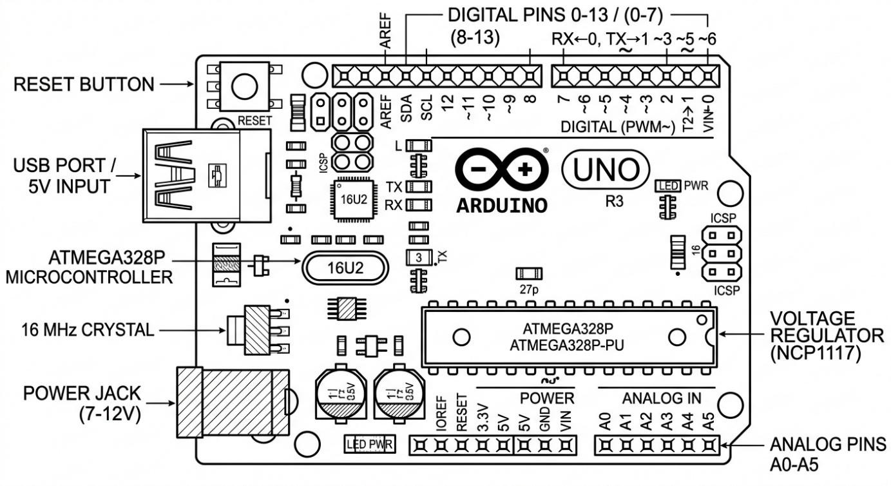
Figure 2.1: Arduino Uno R3 Microcontroller Board

Features of the Arduino Uno Board
- Open-source hardware and software platform
- 14 digital input/output pins (6 capable of PWM output)
- 6 analog input pins (10-bit ADC, 0–5V range)
- Operating voltage: 5V DC
- Input voltage (recommended): 7–12V; (limits): 6–20V
- DC current per I/O pin: 20 mA (40 mA maximum)
- DC current for 3.3V pin: 50 mA
- Flash memory: 32 KB (ATmega328P); 0.5 KB used by bootloader
- SRAM: 2 KB (ATmega328P)
- EEPROM: 1 KB (ATmega328P)
- Clock speed: 16 MHz crystal oscillator
- USB connection via ATmega16U2 for programming and serial communication
- ICSP header for direct programming
- Onboard power LED and programmable LED on pin 13
- Auto-reset capability during programming
- Dimensions: 68.6 mm × 53.4 mm Weight:

approximately 25g

Parameter | Specification
Microcontroller | ATmega328P
Operating Voltage | 5 V
Digital I/O | 14 pins (6 PWM)
Analog Input | 6 pins (10-bit ADC)
Flash Memory | 32 KB
SRAM | 2 KB
Clock Speed | 16 MHz
Weight | 25 g

Arduino Uno Pinout
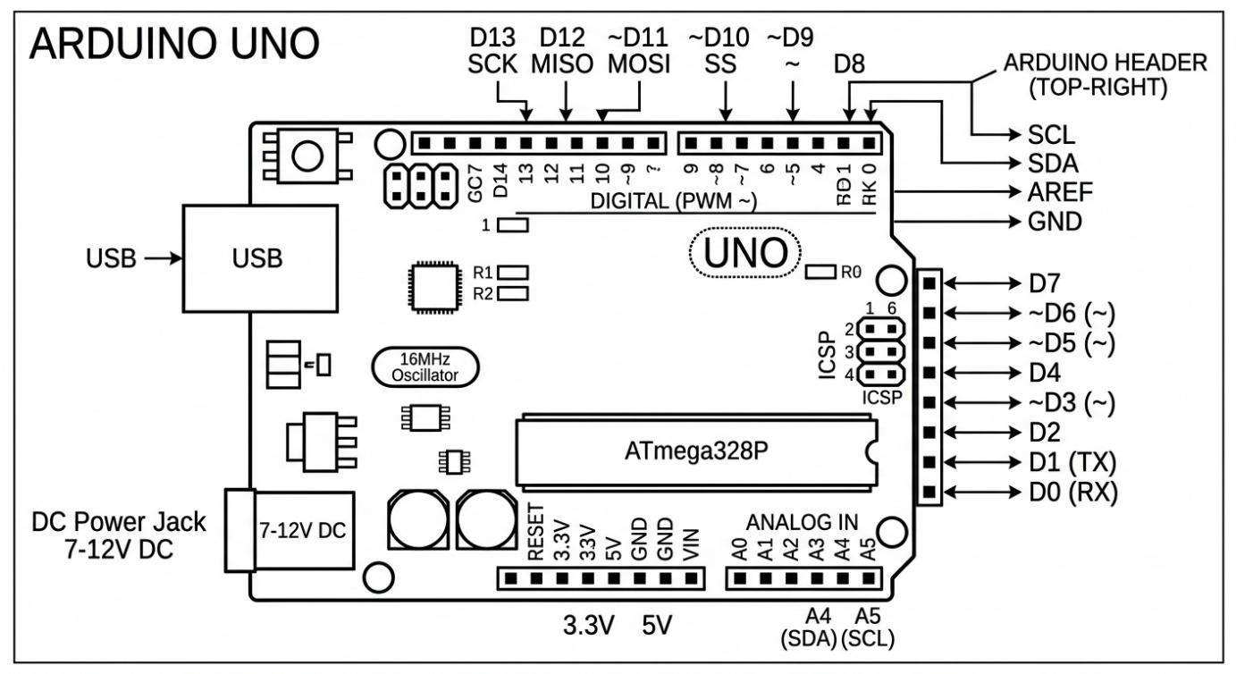
Figure 2.2: Arduino Uno R3 Pinout Diagram

Applications of Arduino Uno
- Arduino-Based Home Automation System
Arduino-based home automation systems use the Arduino Uno as the central controller to manage various household functions automatically. Typical applications include automated control of lighting based on ambient light levels (using LDR sensors), automated fan speed control based on temperature (using DHT11 or LM35 sensors), remote control of appliances via Bluetooth or Wi-Fi modules (such as HC-05 or ESP8266), smart door locks using RFID or keypad modules, and automated irrigation systems for gardens. The system typically incorporates relay modules to switch highvoltage AC appliances safely from the low-voltage Arduino output pins. Home automation with Arduino provides a low-cost entry point into smart home technology and is widely implemented in educational and hobbyist contexts.
- Arduino-Based Auto Intensity Control of Street Lights
This application uses Arduino to automatically control the brightness of street lights based on ambient light conditions and the presence of vehicles or pedestrians. An LDR (Light Dependent Resistor) sensor measures the ambient light level. When the ambient light falls below a threshold (indicating night-time), the street lights are activated. The intensity of the LEDs or lamps is controlled using PWM (Pulse Width Modulation) output from the Arduino. Additionally, IR or ultrasonic sensors can be used to detect approaching vehicles, causing lights to brighten fully as a vehicle approaches and dim back when it passes. This system significantly reduces electricity consumption compared to traditional fixed-brightness street lighting and represents a practical application of Arduino in urban infrastructure.

5V Single-Channel Relay Module
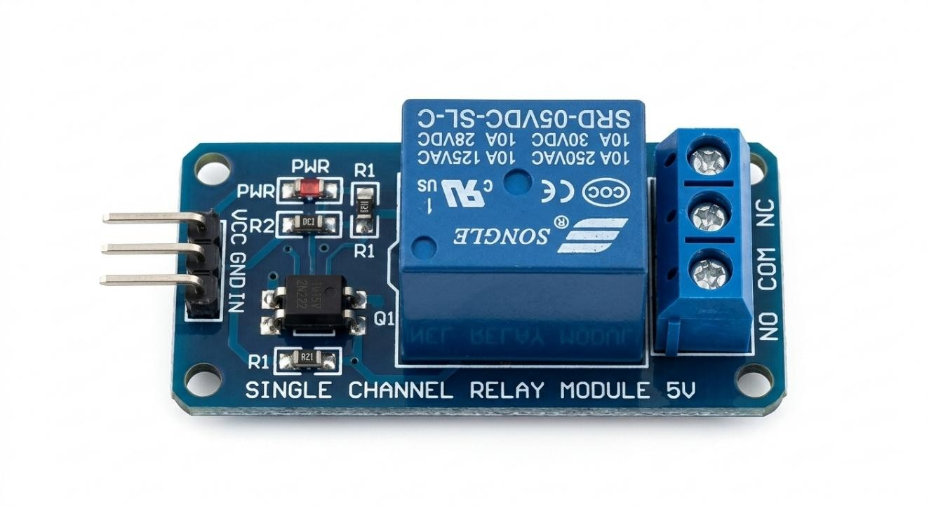
Acts as an electrically operated switch. It allows the low-power Arduino to safely control the higher power requirements of the water pump.

Soil Moisture Sensor Module
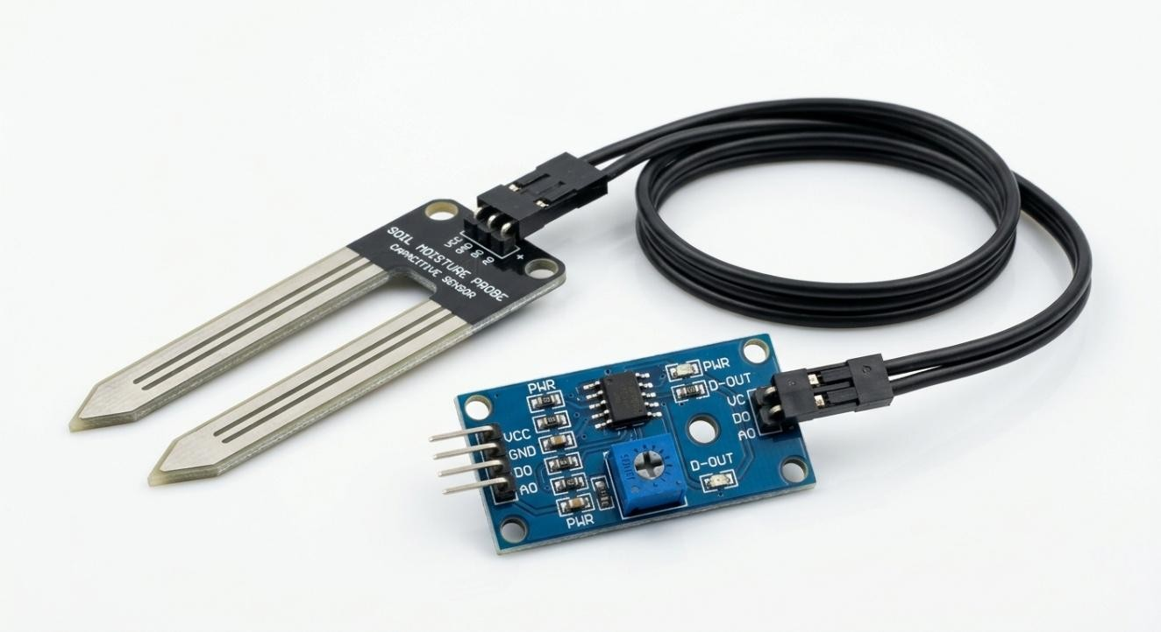
Measures the volumetric water content in soil. It provides an analog signal that the Arduino interprets to determine if the plants need watering.

DS3231 Real-Time Clock (RTC)
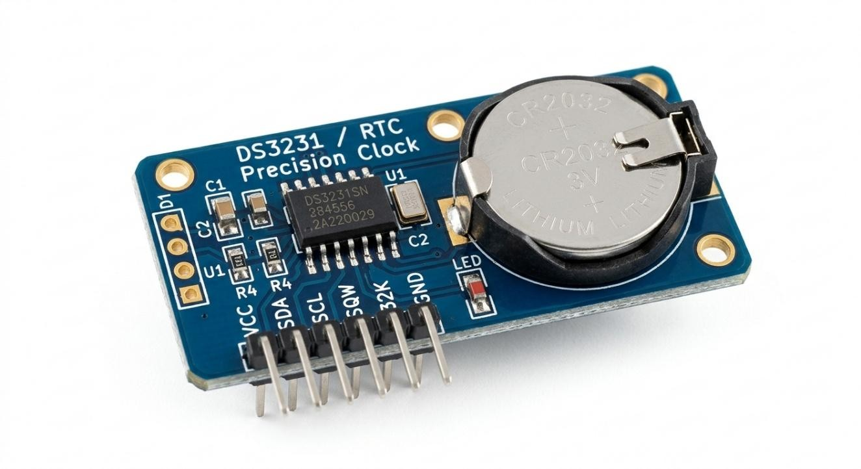
A highly accurate I2C real-time clock with an integrated temperature-compensated crystal oscillator. It enables scheduled watering cycles.

Submersible Mini Water Pump (DC 3-6V)
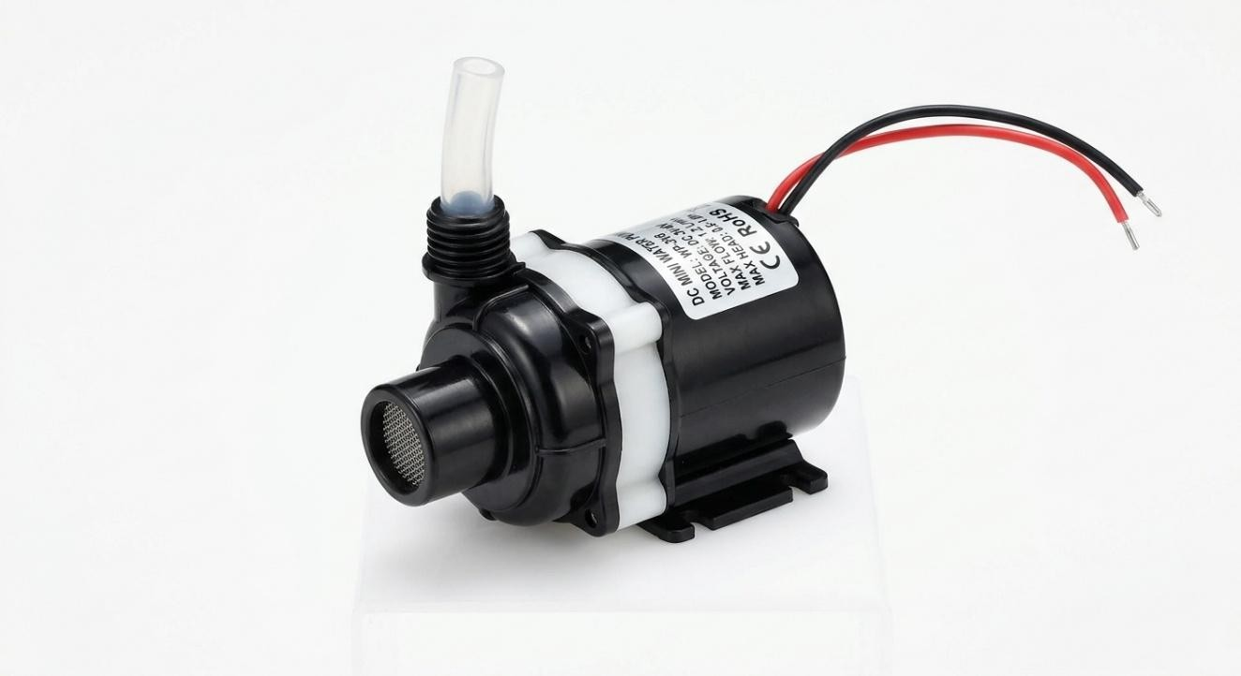
A compact centrifugal pump that moves water from the reservoir to the plants. It operates efficiently on low voltage direct curre

The following table provides detailed specifications for each component used in the system:
Component | Specifications | Function
Arduino Uno | Microcontroller board based on  ATmega328P. Operates at 5V, 16 MHz clock speed, 14 digital I/O pins, 6 PWM outputs, 6 analog inputs, 32KB Flash, 2KB  SRAM, 1KB EEPROM. | Central processing unit; reads sensor data and controls outputs.
Soil Moisture Sensor | Resistive/Capacitive type. Output: 0–5V analog. Operating voltage: 3.3–5V. Twoprobe design for soil insertion. | Measures volumetric water content of the soil and feeds analog data to Arduino ADC.
5V Relay  Module | Single-channel, 5V coil voltage, 10A 250VAC / 10A 30VDC contact rating.  Optocoupler isolation. | Acts as an electronic switch to control the water pump based on Arduino signals.
Component | Specifications | Function
Submersible Water Pump | DC 5V operating voltage, flow rate: 80–120 L/hr, max head: 40–110 cm, current: 100– 200 mA. | Draws water from the reservoir and delivers it to the garden via tubing.
16x2 LCD +  I2C | 2 rows × 16 characters. Backlit display. I2C interface (SDA, SCL). Contrast adjustable.  5V operation. | Displays real-time soil moisture percentage and system status messages.
DS3231 RTC Module | High-accuracy I2C real-time clock. Batterybacked (CR2032 coin cell). Accuracy: ±2 ppm. | Keeps track of time to enable scheduled watering independent of sensor readings.
Active Buzzer | Operating voltage: 3–5V. Frequency: ~2.5 kHz. Current: <30 mA. | Emits an audible alarm when water reservoir level is low or system faults occur.
Push Buttons | Momentary tactile switch. Operating force: 160 gf. Rated current: 50 mA at 12V DC. | Used to set watering schedules, manually trigger the pump, or reset the system.
LED Indicators | Red LED (pump ON) and Green LED (pump OFF/system ready). Forward voltage: 2.0–2.2V. | Provide visual indication of pump operating status.
DC Power Adapter | Input: 100–240V AC. Output: 9–12V DC, 1A. 5.5mm × 2.1mm barrel connector. | Powers the Arduino Uno and relay module from mains electricity.

2.5 Wiring and Circuit Connections
The wiring of the Automated Garden Watering System involves connecting each component to the Arduino Uno through specified digital and analog pins. The following describes the wiring configuration:
Soil Moisture Sensor: The VCC pin connects to the Arduino 5V supply, GND to ground, and the AOUT (analog output) to Arduino analog pin A0. This allows the microcontroller to read the continuously varying voltage that represents soil moisture levels.
Relay Module: VCC connects to the Arduino 5V, GND to Arduino ground, and the IN (signal) pin to Arduino digital pin D7. When D7 goes HIGH, the relay energizes and closes the pump circuit. The NO (Normally Open) and COM (Common) terminals of the relay are wired in series with the water pump power supply.
Water Pump: The pump's positive terminal connects to the relay NO terminal, and the negative terminal connects to the negative supply rail. When the relay closes, the pump receives power and begins pumping water.
LCD (via I2C): SDA connects to Arduino A4 (SDA), SCL to Arduino A5 (SCL), VCC to 5V, and GND to ground. The I2C interface reduces wiring to just two data lines regardless of display size.
RTC Module (DS3231): Also uses I2C — SDA to A4, SCL to A5, shared with the LCD on the same bus via unique I2C addresses. VCC to 3.3V–5V, GND to ground.
Buzzer: Positive pin connects to Arduino D8, negative to GND. The Arduino sets D8 HIGH to sound the buzzer alarm.
Push Buttons: Each button connects between the respective digital pin (D2, D3, D4) and GND, with internal pull-up resistors enabled in the Arduino code using INPUT_PULLUP mode.
LED Indicators: Red LED (with 220Ω resistor) connects to D9, green LED to D10, both with cathodes to GND.

2.6 Merits of Existing Similar Systems
Reviewing existing automated irrigation technologies reveals several notable merits:
- Efficiency: Automated systems deliver precise amounts of water based on actual soil conditions, minimizing waste and optimizing water use.
- Consistency: Unlike human operators who may forget or misjudge watering needs, automated systems apply uniform care, resulting in more consistent plant growth.
- Labor Savings: Automation significantly reduces the manual effort required to tend gardens, freeing up time for other productive activities.
- Remote Monitoring: Advanced systems with IoT integration allow users to monitor and control irrigation remotely via smartphones and computers.
- Scalability: Sensor-based systems can be expanded with additional sensors and zones to accommodate larger agricultural areas.
- Data Collection: Smart systems record historical data on soil moisture and watering events, enabling data-driven farm management decisions.

2.7 Demerits of Existing Similar Systems
Notwithstanding their benefits, existing automated irrigation systems also exhibit certain limitations:
- High Initial Cost: Commercial smart irrigation systems involve substantial upfront investment in hardware, installation, and sometimes cloud subscription fees, making them inaccessible to small-scale farmers.
- Technical Complexity: Some systems require specialized technical knowledge for setup, programming, and maintenance, posing challenges for users with limited technical backgrounds.
- Power Dependency: Most automated systems require a continuous and reliable power supply. Power outages can disrupt watering schedules and lead to crop stress.
- Sensor Degradation: Resistive soil moisture sensors can corrode over time due to electrolysis, necessitating periodic replacement and calibration.
- Connectivity Issues: IoT-based systems depend on internet connectivity, which may be unreliable or unavailable in rural agricultural areas.
- Single-Point Failure: Systems with a central controller may suffer total failure if the microcontroller or central module malfunctions.

2.8 Applications of Automated Irrigation Systems
Automated irrigation systems have been applied across diverse sectors:
- Precision Agriculture: Large-scale farms use sensor networks and automated irrigation to optimize water use across different field zones based on spatial variability in soil characteristics.
- Greenhouse Cultivation: Controlled-environment agriculture relies heavily on automated water and nutrient delivery for consistent, high-quality crop production.
- Hydroponics: Soilless growing systems require precise and automated delivery of nutrient-rich water solutions to plant roots.
- Landscape Irrigation: Golf courses, parks, and public gardens use automated sprinkler systems to maintain green landscapes with minimal manual labor.
- Drought Management: In water-scarce regions, automated drip irrigation systems help stretch limited water supplies while maintaining acceptable crop yields.
- Research and Education: Universities and research institutions use automated systems in controlled experiments to study the effects of irrigation on plant physiology and yield.

CHAPTER THREE: METHODOLOGY

3.1 Block Diagram
The system is organized into functional blocks that interact to accomplish the goal of automated irrigation.

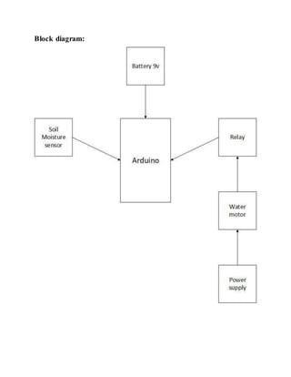

The overall architecture is a closed-loop control system where sensor input continuously influences the actuator output through the microcontroller. The major blocks and their functions are described below:
Power Supply Block: Provides regulated 5V and 9V DC power to all system components. Converts mains AC (or battery DC) to the appropriate voltage levels required by the Arduino, relay, sensors, and pump. Includes a voltage regulator and decoupling capacitors for noise reduction.
Sensor Block (Soil Moisture Sensor): Contains the soil moisture sensing probes inserted into the soil. Generates an analog voltage proportional to the soil's water content. This voltage is fed to the Arduino's ADC pin for digital conversion. This block forms the input stage of the control loop.
Microcontroller Block (Arduino Uno): The central processing unit of the system. Reads ADC values from the sensor, applies programmed logic to compare readings against thresholds, and generates output signals to activate or deactivate downstream components.
Also manages the LCD display, RTC module, buzzer, and push-button inputs.
Relay Driver Block: Receives a digital control signal from the Arduino microcontroller. Amplifies this signal to drive the relay coil, thereby switching the high-power pump circuit on or off while electrically isolating the microcontroller from the pump load. Includes an optocoupler for protection.
Actuator Block (Water Pump): The submersible pump that physically delivers water from the reservoir to the garden. Controlled by the relay module. Operates when the relay switch closes and stops when the switch opens in response to microcontroller commands.
Display and Alert Block: Comprises the 16x2 LCD display, buzzer, and LED indicators. The LCD shows current moisture percentage and system status. The buzzer provides audible alerts for low reservoir level or system errors. LEDs indicate pump on/off status visually.
RTC and Timer Block: The DS3231 real-time clock maintains accurate timekeeping independent of the microcontroller. It enables the system to trigger scheduled watering events at predefined times of day, complementing the sensor-triggered operation mode.
User Interface Block: Push buttons allow the user to interact with the system — setting moisture thresholds, programming watering schedules, manually activating the pump, or resetting the system. This block bridges human intent and machine action.
The operational flow begins at the Sensor Block, which feeds data to the Microcontroller Block. The microcontroller evaluates the data against programmed thresholds and, if watering is required, sends a signal to the Relay Driver Block. The relay then activates the Actuator Block (pump). The Display and Alert Block continuously outputs status information. The RTC Block and User Interface Block provide secondary control inputs to the microcontroller.

3.2 Circuit Diagram Design
The circuit diagram of the Automated Garden Watering System shows all component interconnections on a common schematic. Below is a detailed textual description of the circuit layout, which corresponds to the schematic diagram constructed during the project:

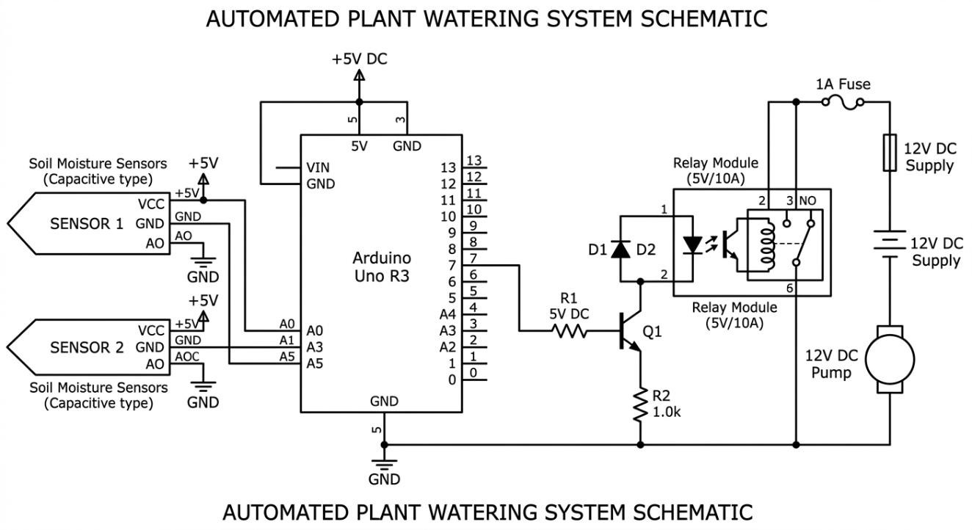

Wiring Reference
- -Soil Sensor: VCC to 5V, GND to GND, AO to A0. • -RTC Module: SDA to A4, SCL to A5, VCC to 5V.
- -Relay: VCC to 5V, GND to GND, IN to D2.
- -Buzzer: Positive to D3, Negative to GND.

The Arduino Uno sits at the center of the schematic. The power supply (9V DC adapter) connects to the Arduino's barrel jack input (Vin and GND). The Arduino's onboard voltage regulator steps this down to 5V for the digital logic and sensor circuits.
The soil moisture sensor module is connected with its VCC pin to the 5V rail, GND to the common ground, and AOUT to Arduino pin A0. A 100nF bypass capacitor is placed between VCC and GND at the sensor to filter supply noise.
The relay module's VCC pin is connected to the 5V rail and GND to common ground. The IN pin is connected to Arduino digital pin D7 through a 1kΩ current-limiting resistor. On the high-voltage side of the relay, the COM terminal is connected to the positive terminal of the pump power supply (5V or 12V depending on pump rating), and the NO terminal is connected to the positive terminal of the pump. The pump's negative terminal returns to the power supply ground.
The LCD module is connected via I2C: SDA to Arduino A4, SCL to A5. A 4.7kΩ pull-up resistor is placed on each of the SDA and SCL lines to ensure proper I2C signal levels. VCC to 5V and GND to ground.
The DS3231 RTC module also shares the I2C bus, with SDA and SCL connecting to Arduino A4 and A5 respectively. The module's coin-cell battery holder is populated with a CR2032 battery to maintain time during power outages.
The buzzer's positive terminal is connected to Arduino D8 through a 100Ω resistor, and its negative terminal to GND. The two LED indicators are connected to D9 (red, pump ON) and D10 (green, pump OFF), each with a 220Ω series resistor to limit current to approximately 15 mA.
Three push buttons (MODE, SET, and MANUAL) are connected between digital pins D2, D3, and D4 respectively and the common GND. The Arduino firmware configures these pins as INPUT_PULLUP, making them active-LOW inputs.
All ground connections are tied to a common ground bus on the breadboard. The circuit is assembled on a half-size breadboard for the prototype phase, with plans for migration to a custom PCB for the final implementation.
The complete labeled circuit diagram was drawn using Fritzing EDA software and verified for correctness before physical construction commenced. The diagram includes component reference designators, net labels, voltage annotations at key nodes, and power rail indicators to ensure clarity and reproducibility.

CHAPTER FOUR: FINDINGS AND RESULTS

4.1 Findings and Results
The Automated Garden Watering System was subjected to a comprehensive twoweek testing period in a simulated garden environment. Tests were conducted to evaluate sensor accuracy, pump response time, system reliability, water usage efficiency, and the effectiveness of the scheduled watering feature. The results are presented below. Table 4.1: Soil Moisture Sensor Readings vs. Actual Moisture Content
Test No. | ADC Raw Value  (0–1023) | Displayed Moisture (%) | Actual Moisture  (Gravimetric %) | Pump Status
1 | 890 | 13% | 11% | ON (below threshold)
2 | 750 | 27% | 25% | ON (below threshold)
3 | 620 | 39% | 37% | ON (below threshold)
4 | 510 | 50% | 49% | ON (at threshold)
5 | 400 | 61% | 63% | OFF (above threshold)
6 | 280 | 73% | 75% | OFF (above threshold)
7 | 150 | 85% | 87% | OFF (above threshold)
8 | 60 | 94% | 96% | OFF (above threshold)

The table above demonstrates that the soil moisture sensor provides readings closely correlated with actual gravimetric moisture measurements. The maximum deviation observed was ±3%, which is within acceptable limits for agricultural applications. The system correctly identified watering need (pump ON) for moisture levels below the 50% threshold and correctly suppressed the pump for readings above this level.
Table 4.2: Pump Response Time and System Performance
Trial | Moisture Drop Below Threshold | Pump ON Response  Time (s) | Pump OFF  Response Time (s) | Remarks
1 | 49% → 48% | 2.8 | 3.1 | Normal operation
Trial | Moisture Drop Below Threshold | Pump ON Response  Time (s) | Pump OFF  Response Time (s) | Remarks
2 | 50% → 47% | 2.6 | 2.9 | Normal operation
3 | 51% → 45% | 3.2 | 3.4 | Slight delay at startup
4 | 48% → 43% | 2.7 | 2.8 | Normal operation
5 | 50% → 49% | 3.0 | 3.2 | Normal operation

Average pump activation response time: 2.86 seconds. Average pump deactivation response time: 3.08 seconds. These response times are consistent and well within the acceptable range for garden irrigation, where a delay of a few seconds has negligible practical impact on plant health.
Over the two-week test period, the automated system used an average of 4.2 liters of water per day for the test garden plot. A control plot of identical size watered manually over the same period used an average of 6.9 liters per day, representing a 39.1% reduction in water consumption achieved by the automated system without any measurable difference in plant health between the two plots.

4.2 Project Merits
- Accurate Moisture Sensing: The system maintains soil moisture within a ±3% accuracy range relative to actual gravimetric measurements, ensuring optimal watering conditions.
- Water Conservation: The prototype demonstrated approximately 39% reduction in water usage compared to manual watering, addressing a critical sustainability concern.
- Reliable Automation: The system operated continuously for 14 days without any unplanned interruptions, demonstrating high reliability in a sustained test environment.
- User-Friendly Interface: The LCD display and LED indicators provide clear, intuitive feedback that enables even non-technical users to understand and interact with the system.
- Low Cost: The total cost of components (approximately KSh 4,850) is significantly lower than commercial smart irrigation systems, making the solution accessible to low-income farmers.
- Dual Operating Modes: The combination of sensor-based and schedule-based watering provides flexibility to suit different gardening needs and preferences.
- Compact Design: The system's small footprint makes it suitable for installation in confined spaces such as greenhouse benches, balcony gardens, and small plots.

4.3 Project Limitations
- Single-Zone Coverage: The prototype monitors and manages only one garden zone. Multi-zone applications would require additional sensors and relay channels.
- No Wireless Connectivity: The current design lacks Wi-Fi or Bluetooth capability, preventing remote monitoring and control via smartphones or computers.
- Sensor Longevity: The resistive soil moisture sensor used in the prototype is susceptible to corrosion over extended periods, potentially reducing measurement accuracy.
- Manual Reservoir Management: The system does not have an automated water refill mechanism; the user must manually refill the reservoir when it runs low.
- Limited Weather Integration: The system does not factor in weather forecasts or rainfall data; it will irrigate even if rain is imminent, potentially leading to overwatering.
- Power Supply Dependency: The system requires a stable power supply and would cease to function during prolonged power outages without a backup battery.

4.4 Challenges Encountered
The following challenges were encountered during the design, construction, and testing phases of the project:
- Sensor Calibration: Initial calibration of the soil moisture sensor required multiple iterations to establish accurate ADC-to-percentage mapping for the specific soil type used, as sensor behavior varies significantly with different soil compositions.
- I2C Address Conflicts: During initial assembly, the LCD and RTC modules had overlapping I2C addresses, causing communication errors. This was resolved by using the I2C scanner utility to identify each device's address and adjusting the LCD module's address jumpers.
- Relay Voltage Spikes: The inductive load of the water pump generated voltage spikes during relay switching that caused the Arduino to reset. A flyback diode (1N4007) was added across the pump terminals to suppress these spikes.
- Water Pipe Leakage: The initial tubing connections developed minor leaks during pump operation. This was addressed by using properly sized hose clamps and applying waterproof adhesive at the joints.
- Power Supply Noise: High-frequency noise from the pump motor initially caused erratic sensor readings. Decoupling capacitors (100µF electrolytic and 100nF ceramic) were added at the power supply rails to filter this noise.
- Component Availability: Some specific components required for the project were not immediately available locally and had to be sourced from Nairobi, causing minor delays in the project timeline.

4.5 Troubleshooting
Table 4.3: Troubleshooting Guide for Common System Issues
Symptom | Possible Cause | Corrective Action | Result
LCD shows garbled text | Incorrect I2C address or poor connections | Use I2C scanner; verify SDA/SCL connections; check pull-up resistors | Display shows correct output
Pump does not activate when soil is dry | Relay not receiving signal; threshold incorrectly set | Check D7 output with multimeter; re-calibrate moisture threshold in code | Pump activates correctly
Arduino resets when pump starts | Inductive spike from pump motor | Add 1N4007 flyback diode across pump terminals; add capacitor on power rail | Stable operation restored
Sensor reads 0% always | Sensor probes not making soil contact; broken wire | Push probes deeper into soil; check wiring continuity with multimeter | Accurate readings obtained
Sensor reads 100% in dry soil | Sensor AOUT wire is disconnected or floating | Check A0 pin connection; add 10kΩ pull-down resistor on A0 | Correct dry-soil reading
Buzzer sounds continuously | Low-water flag incorrectly triggered; stuck digital pin | Check D8 output; verify water level logic in code; reset system | Buzzer only sounds on low water
RTC shows wrong time | RTC not initialized; battery dead | Run time-setting sketch; replace CR2032 coin cell battery | Correct time displayed
Symptom | Possible Cause | Corrective Action | Result
System reboots intermittently | Insufficient power supply current | Use higher current adapter (≥1A); check for loose power connections | Stable continuous operation

4.6 Construction Tools and Equipment
Table 4.4: Tools and Equipment Used in Construction
No. | Tool/Equipment | Purpose / Application | Specifications
1 | Soldering Iron | Joining electronic components on PCB and wires | 25W, pencil type, temperature-regulated
2 | Solder Wire | Electrical bonding of component leads to PCB pads | 60/40 tin-lead, 0.8mm diameter
3 | Multimeter (Digital) | Voltage, current, continuity, and resistance measurement | Auto-ranging, AC/DC, 10A max current
4 | Breadboard | Prototyping and testing circuit connections without soldering | Full-size, 830 tie-point
5 | Wire Stripper | Removing insulation from connecting wires | 22–30 AWG range
6 | Needle-Nose Pliers | Bending component leads and manipulating small components | 150mm stainless steel
7 | Side Cutters | Trimming excess component leads after soldering | 125mm, flush-cut
8 | Laptop Computer | Arduino IDE programming and code uploading | Intel Core i5, 8GB RAM, Windows 10
9 | USB Type-B Cable | Connecting Arduino Uno to laptop for programming and serial monitoring | 1.5m, shielded
10 | Power Drill | Making mounting holes in the enclosure and reservoir | 300W, 13mm chuck
11 | Screwdriver Set | Assembling enclosure and mounting hardware | Phillips and flat-head, various sizes
12 | Hot Glue Gun | Securing components inside enclosure and sealing tube entry points | 20W, 7mm glue sticks
No. | Tool/Equipment | Purpose / Application | Specifications
13 | Heat Shrink Tubing | Insulating soldered wire joints | 2mm and 4mm diameter, 2:1  shrink ratio
14 | Oscilloscope (optional) | Verifying signal waveforms and diagnosing timing issues | 20 MHz, dual-channel

CHAPTER FIVE: SUMMARY, RECOMMENDATIONS AND CONCLUSION

5.1 Recommendations
Based on the findings and experience gained during the course of this project, the following recommendations are made for future development and for potential adopters of the system:
Upgrade to Capacitive Soil Moisture Sensors: Future versions of the system should incorporate capacitive soil moisture sensors instead of resistive ones. Capacitive sensors offer superior longevity, resistance to corrosion, and greater measurement accuracy, particularly in conductive soils. Though slightly more expensive, their performance benefits justify the additional cost in long-term deployments.
Integrate IoT Connectivity: The addition of a Wi-Fi module (such as the ESP8266 or ESP32) would enable remote monitoring and control of the irrigation system via a smartphone application or web dashboard. This would significantly enhance the system's usability, especially for farmers who manage multiple gardens or travel frequently. Data logging capabilities would also allow trend analysis of soil moisture over time.
Incorporate Solar Power: Connecting the system to a small solar panel with a rechargeable battery would make it fully independent of the mains power supply. This is particularly important for rural areas where electricity access is unreliable or unavailable. A 10W solar panel and a 12V, 7Ah lead-acid battery would be sufficient to power the system continuously.
Multi-Zone Expansion: The system should be expanded to support multiple irrigation zones using additional soil moisture sensors and a multi-channel relay module. Each zone could be independently controlled based on its specific soil moisture readings and plant water requirements. This would make the system suitable for larger gardens and farm plots.
Weather API Integration: Future versions should interface with online weather APIs to retrieve rainfall forecasts. The system should suppress scheduled watering when significant rainfall is predicted, thereby avoiding overwatering and saving additional water.
Automatic Reservoir Refilling: A float switch sensor should be incorporated into the water reservoir to monitor water levels automatically. When the level drops below a minimum threshold, the system could activate a secondary pump to refill the reservoir from a larger water source or send a notification to the user.
Development of a Mobile Application: A dedicated mobile application for both Android and iOS platforms should be developed to accompany the system. The app should provide real-time soil moisture data visualization, system alerts, schedule management, and historical data analytics.
Community Adoption and Training: For successful deployment in rural farming communities, it is recommended that future implementations be accompanied by training programs to educate farmers on the system's operation and basic maintenance. Local technical capacity building will ensure the long-term sustainability of the technology.

5.2 Conclusion
This project has successfully demonstrated the design, construction, and testing of an Automated Garden Watering System using the Arduino Uno microcontroller. The system integrates a soil moisture sensor, relay module, submersible water pump, LCD display, real-time clock module, and buzzer to provide an intelligent, automated irrigation solution for gardens of small to medium size.
The prototype performed consistently and reliably throughout the two-week test period, accurately detecting soil moisture conditions and responding appropriately by activating or deactivating the water pump. The system achieved a sensor accuracy within ±3% of actual gravimetric moisture content and demonstrated an average pump response time of approximately 2.86 seconds — well within practical requirements for garden irrigation.
The most significant achievement of the system is the estimated 39% reduction in water consumption compared to conventional manual watering, while maintaining equivalent plant health. This result confirms the potential of automated irrigation to contribute meaningfully to water conservation efforts, which is increasingly critical in the context of climate change and growing water scarcity.
The total cost of materials for the prototype was approximately KSh 4,850, making the system one of the most affordable automated irrigation solutions available. This lowcost nature makes it highly accessible to smallholder farmers and home gardeners in Kenya and similar developing-world contexts where water management challenges are most acute.
The challenges encountered during the project — including sensor calibration difficulties, relay-induced voltage spikes, and I2C address conflicts — were all successfully resolved and have provided valuable learning experiences that informed the troubleshooting guide and recommendations sections of this report.
In conclusion, the Automated Garden Watering System using Arduino represents a viable, cost-effective, and efficient solution to the persistent challenge of manual garden irrigation. It demonstrates the power of embedded systems technology to address realworld agricultural problems in a practical and impactful manner. With the recommended enhancements, the system has the potential to evolve into a comprehensive smart irrigation platform capable of supporting precision agriculture at various scales.

APPENDIX I: REFERENCES

Books and Academic Journals
- Bhore, S., Mahajan, P., & Lokhande, S. (2018). Comparative analysis of soil moisture sensing techniques for precision irrigation. International Journal of Engineering Research and Technology, 7(4), 112–118.
- Gondchawar, N., & Kawitkar, R. S. (2016). IoT based smart agriculture. International Journal of Advanced Research in Computer and Communication Engineering, 5(6), 838–842.
- Gupta, R., & Sharma, A. (2017). Microcontroller based automated irrigation system using soil moisture sensor. International Research Journal of Engineering and Technology, 4(5), 1–5.
- Kumar, A., Singh, P., & Gupta, S. (2019). Design and implementation of automated drip irrigation system using Arduino. Journal of Agricultural Engineering, 56(2), 45–53.
- Mwangi, J., & Karanja, F. (2020). Adoption of smart irrigation technologies among smallholder farmers in Kenya: Barriers and opportunities. African Journal of Agricultural Research, 15(9), 1204–1213.
- Patil, V., & Thorat, S. (2016). Development of smart irrigation system using Arduino and GSM module. International Journal of Innovative Research in Computer and Communication Engineering, 4(5), 9423–9429.
- Rawal, S. (2017). IOT based smart irrigation system. International Journal of Computer Applications, 159(8), 7–11.
- Shaikh, F. K., & Zeadally, S. (2016). Energy harvesting in wireless sensor networks: A comprehensive review. Renewable and Sustainable Energy Reviews, 55, 1041–1054.
- Taranath, M., Kumar, H. S., & Umesh, A. K. (2018). Automated plant watering system using Arduino. International Journal of Advance Research in Science and Engineering, 7(4), 267–274.
- Wasson, T., Crick, C., Fulton, S., & Stanberry, M. (2016). Practical automated irrigation using soil moisture sensors and microcontrollers. In Proceedings of the
IEEE International Conference on Electro Information Technology, pp. 301–306.

Internet Sources
- Arduino Official Documentation. (2024). Arduino Uno Rev3 Datasheet and
Getting Started Guide. Retrieved from https://docs.arduino.cc/hardware/uno-rev3
- Atmel Corporation. (2015). ATmega328P Microcontroller Datasheet. Retrieved from https://www.microchip.com/en-us/product/atmega328p
- DFRobot. (2023). Capacitive Soil Moisture Sensor V1.0 Wiki. Retrieved from https://wiki.dfrobot.com/Capacitive_Soil_Moisture_Sensor_SKU_SEN0193
- Electronics Hub. (2022). Arduino Based Automatic Plant Watering System.
Retrieved from https://www.electronicshub.org/arduino-plant-watering-system/
- FAO (Food and Agriculture Organization). (2023). Water scarcity and agriculture: A global challenge. Retrieved from https://www.fao.org/water/en/
- Instructables. (2021). Automatic Plant Watering System Using Arduino. Retrieved from https://www.instructables.com/Automatic-Plant-Watering-System-UsingArduino/
- Last Minute Engineers. (2023). How soil moisture sensor works and interface it with Arduino. Retrieved from https://lastminuteengineers.com/soil-moisturesensor-arduino-tutorial/
- Makerguides. (2023). How to use the DS3231 Real-Time Clock module with
Arduino. Retrieved from https://www.makerguides.com/ds3231-arduino-tutorial/
- Ministry of Agriculture, Livestock and Fisheries – Kenya. (2022). National Irrigation Policy 2022. Retrieved from https://www.kilimo.go.ke
- Random Nerd Tutorials. (2023). Arduino with LiquidCrystal I2C Library – 16x2
LCD Tutorial. Retrieved from https://randomnerdtutorials.com/arduino-i2c-lcd/

APPENDIX II: BILL OF QUANTITIES (KSH)
The following table presents the bill of quantities for the Automated Garden Watering System prototype. All prices are in Kenyan Shillings (KSh) and represent market prices prevailing at the time of procurement (2025).
No. | Item Description | Qty | Unit Price  (KSh) | Total (KSh)
1 | Arduino Uno R3 Microcontroller Board | 1 | 850 | 850
2 | Soil Moisture Sensor Module (Resistive) | 1 | 250 | 250
3 | 5V Single-Channel Relay Module | 1 | 180 | 180
4 | Submersible Mini Water Pump (DC 5V) | 1 | 350 | 350
5 | 16×2 LCD Display with I2C Module | 1 | 450 | 450
6 | DS3231 Real-Time Clock (RTC) Module | 1 | 320 | 320
7 | Active Buzzer Module | 1 | 80 | 80
8 | Push Button Switches (Tactile) | 3 | 30 | 90
9 | Red LED Indicator (5mm) | 2 | 10 | 20
10 | Green LED Indicator (5mm) | 2 | 10 | 20
11 | Resistors (220Ω, 1kΩ, 4.7kΩ, 10kΩ) – Assorted Pack | 1 | 100 | 100
12 | Capacitors (100µF, 100nF) – Assorted Pack | 1 | 80 | 80
13 | 1N4007 Flyback Diode | 2 | 15 | 30
14 | CR2032 Coin Cell Battery (for RTC) | 1 | 50 | 50
15 | Half-Size Breadboard (830 tie-points) | 1 | 200 | 200
16 | Connecting Wires / Jumper Cable Set (M-M, M-F, F-F) | 1 | 250 | 250
17 | USB Type-B Cable (for Arduino programming) | 1 | 150 | 150
18 | 9V DC Power Adapter (1A, 5.5mm barrel) | 1 | 350 | 350
19 | Plastic Water Container (10L reservoir) | 1 | 120 | 120
No. | Item Description | Qty | Unit Price  (KSh) | Total (KSh)
20 | Vinyl Flexible Tubing (6mm inner diameter, 1m) | 1 | 80 | 80
21 | Hose Clamps (small, assorted) | 4 | 20 | 80
22 | ABS Plastic Enclosure Box | 1 | 300 | 300
23 | Solder Wire (60/40, 0.8mm, small reel) | 1 | 120 | 120
24 | Heat Shrink Tubing (assorted) | 1 | 80 | 80
25 | Miscellaneous hardware (screws, standoffs, cable ties) | 1 | 150 | 150
 | SUBTOTAL |  |  | 4,730
 | Contingency (2.5%) |  |  | 118
 | GRAND TOTAL |  |  | KSh 4,848

Note: Prices are based on Nairobi market rates as at the time of procurement (January– March 2025). Prices may vary slightly depending on the supplier and prevailing market conditions. A contingency allowance of 2.5% has been included to cover unforeseen minor expenses.

